Virtual Network Simulation: Design, Monitoring and Troubleshooting
Building, monitoring and troubleshooting a routed network in Cisco Packet Tracer
Prepared by | Elyas Ghwiet
Program | Yuva virtual internship - IT / Network Support task
Simulation software | Cisco Packet Tracer
Date | October 2026 (first week)

Executive summary
This report documents a small-scale virtual network built in Cisco Packet Tracer to practise establishing, maintaining and troubleshooting network systems. The network joins two LANs through two routers running RIPv2. Monitoring was implemented with ping, traceroute, Syslog and SNMP, and packet flow was inspected in Simulation mode. Three realistic faults (a shut-down router interface, a wrong default gateway and a removed routing process) were introduced, diagnosed and resolved, and the evidence for each is shown in the sections below.
- Topology: 2 routers, 2 switches, 4 PCs and 1 server across two subnets joined by a /30 link.
- Monitoring: ICMP (ping), traceroute, Syslog to Server0, SNMPv2c queries from PC1, and Simulation-mode packet capture.
- Troubleshooting: 3 incidents documented with symptom, diagnosis, root cause, resolution and verification.

1. Introduction and objectives
Network maintenance depends on three habits: knowing what a healthy network looks like, watching it continuously, and following a repeatable method when something breaks. The objective of this task was to build a small environment where all three can be practised safely.
- Select suitable simulation software and justify the choice.
- Design a topology with routers, switches and at least two end nodes.
- Implement monitoring tools (ping, traceroute, SNMP, Syslog) inside the simulation.
- Simulate network issues, then document the troubleshooting steps and resolutions.
- Compile the configuration, evidence and analysis into this report.

2. Simulation software selection
Three common options were compared before starting.
Criterion | Cisco Packet Tracer | GNS3 | Virtual machines (VirtualBox / VMware)
Cost | Free with a Networking Academy account | Free, but needs router images | Free hypervisor, OS licences vary
Hardware needs | Low (runs on a normal laptop) | Medium to high | High (one VM per device)
Learning curve | Gentle; graphical, built-in devices | Steeper; image and server setup | Steep; manual OS and network setup
Router / switch CLI | Cisco IOS-style CLI | Real IOS images | Depends on software router
SNMP, Syslog, Simulation mode | Built in (MIB Browser, Syslog service, packet capture) | External tools needed | External tools needed

Decision: Cisco Packet Tracer was selected. It provides everything the task requires in a single tool - IOS-style configuration, an SNMP MIB Browser, a Syslog service on the server and a packet-level Simulation mode - and it runs comfortably on a standard laptop. Its main limitation is that devices are simulated, so a few advanced IOS features are unavailable; none of them were needed here.

3. Network design

3.1 Topology
The design uses two LANs, each with its own switch and default gateway, connected by a point-to-point /30 link between two routers. A server in LAN1 acts as the Syslog collector, and PC1 acts as the SNMP management station. Keeping the monitoring tools in LAN1 means traffic from Router2 must cross the router link to reach them, which also tests routing.
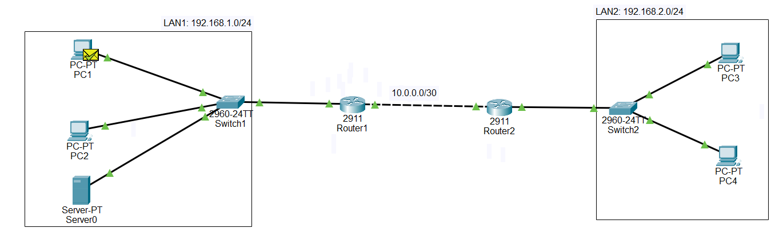
Figure 1: Network topology as built in Cisco Packet Tracer (Logical view).
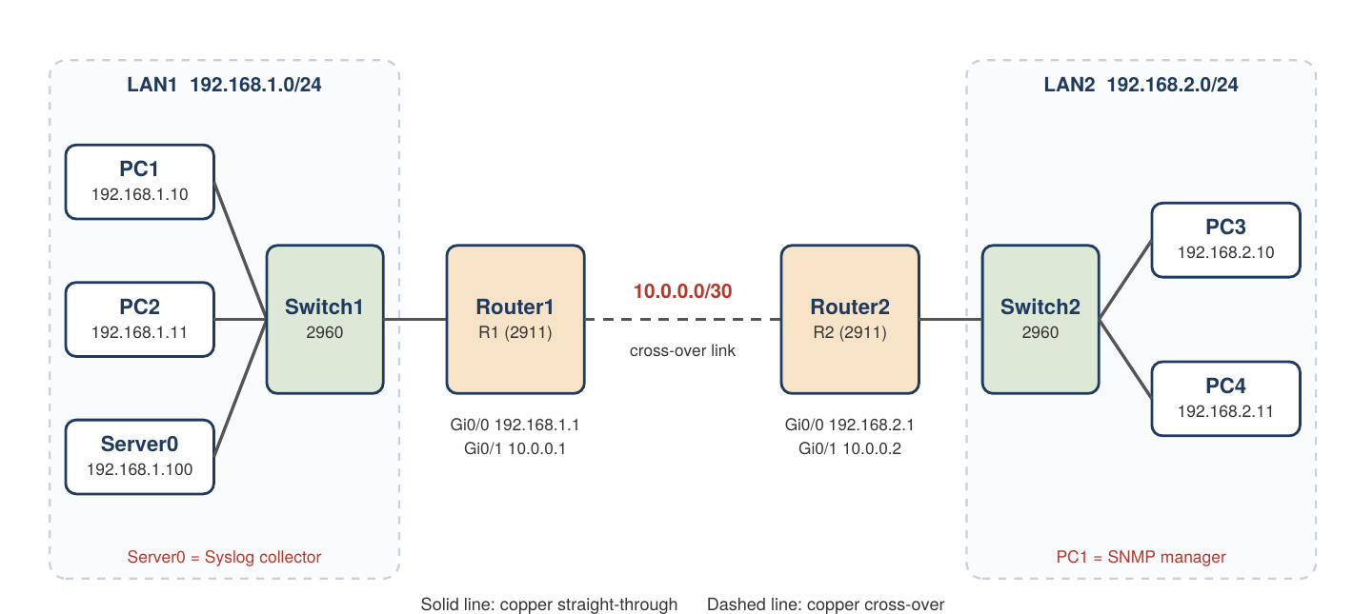
Figure 2: Logical topology with interfaces and IP addressing.

3.2 Device inventory
Device | Model | Hostname | Role
Router1 | Cisco 2911 | R1 | Default gateway for LAN1; RIPv2; SNMP agent; Syslog client
Router2 | Cisco 2911 | R2 | Default gateway for LAN2; RIPv2; SNMP agent; Syslog client
Switch1 | Cisco 2960-24TT | - | Layer 2 access switch for LAN1
Switch2 | Cisco 2960-24TT | - | Layer 2 access switch for LAN2
PC1, PC2 | PC-PT | - | LAN1 clients; PC1 is also the SNMP manager
PC3, PC4 | PC-PT | - | LAN2 clients
Server0 | Server-PT | - | Syslog collector for both routers

3.3 IP addressing plan
Device | Interface | IP address | Subnet mask | Default gateway
R1 | Gi0/0 (to Switch1) | 192.168.1.1 | 255.255.255.0 | -
R1 | Gi0/1 (to R2) | 10.0.0.1 | 255.255.255.252 | -
R2 | Gi0/0 (to Switch2) | 192.168.2.1 | 255.255.255.0 | -
R2 | Gi0/1 (to R1) | 10.0.0.2 | 255.255.255.252 | -
PC1 | FastEthernet0 | 192.168.1.10 | 255.255.255.0 | 192.168.1.1
PC2 | FastEthernet0 | 192.168.1.11 | 255.255.255.0 | 192.168.1.1
Server0 | FastEthernet0 | 192.168.1.100 | 255.255.255.0 | 192.168.1.1
PC3 | FastEthernet0 | 192.168.2.10 | 255.255.255.0 | 192.168.2.1
PC4 | FastEthernet0 | 192.168.2.11 | 255.255.255.0 | 192.168.2.1

3.4 Cabling plan
From | To | Cable type
PC1, PC2, Server0 | Switch1 (Fa0/2, Fa0/3, Fa0/4) | Copper straight-through
Switch1 Fa0/1 | Router1 Gi0/0 | Copper straight-through
Router1 Gi0/1 | Router2 Gi0/1 | Copper cross-over (router to router)
Router2 Gi0/0 | Switch2 Fa0/1 | Copper straight-through
PC3, PC4 | Switch2 (Fa0/2, Fa0/3) | Copper straight-through

Design choices. RIP version 2 was chosen because it exchanges routes automatically, so a failed link or a removed routing process shows up immediately in the routing tables - ideal for the troubleshooting exercises. A /30 subnet is used for the router link because it needs only two usable addresses. Switches run with default settings since both LANs are single-VLAN.

4. Configuration
All devices were configured from the CLI (routers) or the IP Configuration panel (hosts). The complete command listings are in Appendix A; the essential parts are summarised here.

4.1 Interfaces and routing
Router1 (Router2 is configured symmetrically with 192.168.2.1 and 10.0.0.2)
R1(config)# interface gigabitEthernet 0/0
R1(config-if)# ip address 192.168.1.1 255.255.255.0
R1(config-if)# no shutdown
R1(config)# interface gigabitEthernet 0/1
R1(config-if)# ip address 10.0.0.1 255.255.255.252
R1(config-if)# no shutdown
R1(config)# router rip
R1(config-router)# version 2
R1(config-router)# network 192.168.1.0
R1(config-router)# network 10.0.0.0
R1(config-router)# no auto-summary

4.2 Monitoring services
Applied on both routers
! Syslog: send router logs to Server0
logging host 192.168.1.100
! SNMP: read-only and read-write community strings
snmp-server community public ro
snmp-server community private rw

On Server0 the SYSLOG service was switched on (Services tab). PC1 uses the built-in MIB Browser with address 192.168.1.1 or 192.168.2.1, read community public and SNMP version v2c.

5. Monitoring and verification

5.1 Interface and routing tables
The first check after configuration is whether interfaces are up and whether routes are learned. On Router2 both configured interfaces report up / up; the third interface and Vlan1 are unused and administratively down by default.
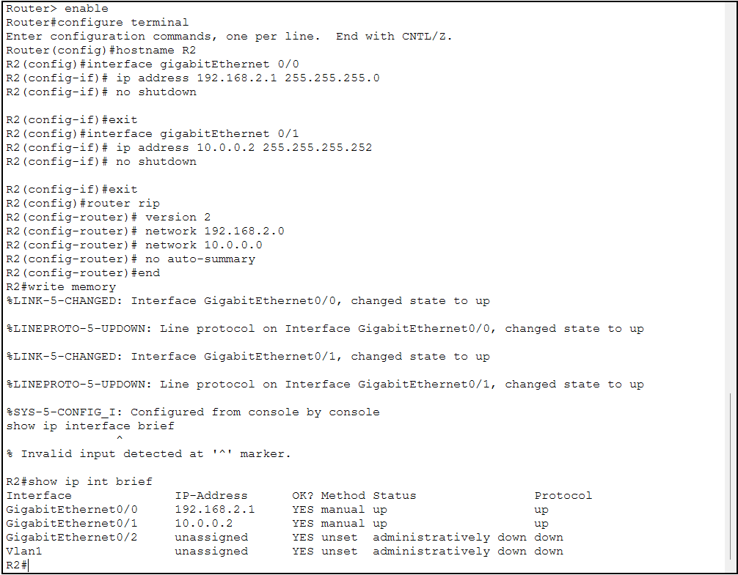
Figure 3: Router2: show ip int brief - Gi0/0 (192.168.2.1) and Gi0/1 (10.0.0.2) are up/up.
On Router1 the routing table contains the two connected networks (C and L entries) and a R entry, proving that RIP learned the LAN2 prefix from Router2 across the 10.0.0.0/30 link. The administrative distance and metric are [120/1], i.e. RIP, one hop away.
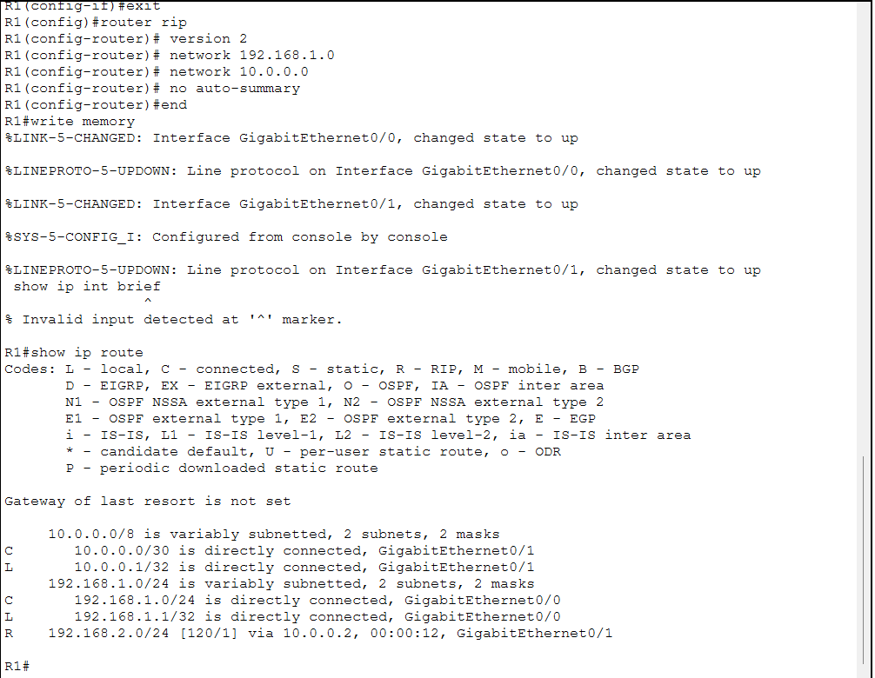
Figure 4: Router1: show ip route - 192.168.2.0/24 learned via RIP from 10.0.0.2.

5.2 Ping and traceroute
Ping verifies reachability and round-trip time; traceroute shows the path hop by hop. From PC1 to PC3:
- Ping: replies arrive from 192.168.2.10 with TTL=126 (initial value 128 minus two router hops). The first request timed out because PC1 had to resolve the gateway MAC address with ARP; the remaining requests succeeded (3/4 received).
- Traceroute: three hops - 192.168.1.1 (Router1), 10.0.0.2 (Router2) and the destination 192.168.2.10 - confirming the path.
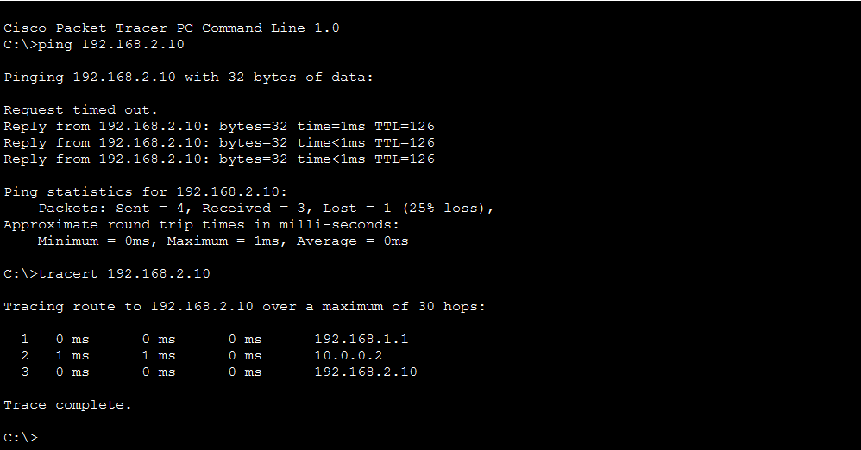
Figure 5: PC1: ping and tracert to PC3 (192.168.2.10).

5.3 Syslog
Both routers send their event messages to Server0. To generate real events, the Gi0/1 interface on Router1 was shut down and brought back up. The Syslog table below shows the configuration change and the link and line-protocol transitions as they were reported, together with the source address of each router.
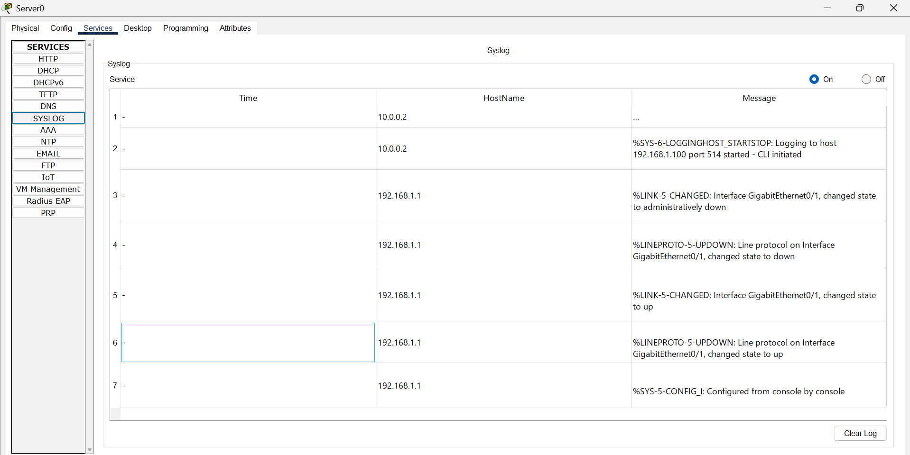
Figure 6: Server0 Syslog service receiving messages from Router1 (192.168.1.1) and Router2 (10.0.0.2).
Message | Meaning
%SYS-6-LOGGINGHOST_STARTSTOP ... started | Router began sending logs to 192.168.1.100 on UDP port 514
%SYS-5-CONFIG_I: Configured from console | Someone changed the configuration from the console
%LINK-5-CHANGED ... administratively down | Interface Gi0/1 was shut down manually
%LINEPROTO-5-UPDOWN ... down | Layer 2 protocol on the interface stopped
%LINK-5-CHANGED ... up / %LINEPROTO ... up | Interface and protocol recovered after no shutdown

Severity levels are encoded in the message code: level 5 is a notification and level 6 is informational.

5.4 SNMP
SNMPv2c was enabled on both routers. From PC1, the MIB Browser sent Get requests to each router. The queried objects belong to the standard MIB-2 system group:
Object | OID | Result
sysDescr.0 | .1.3.6.1.2.1.1.1.0 | Cisco IOS Software, C2900 Software (C2900-UNIVERSALK9-M)
sysName.0 | .1.3.6.1.2.1.1.5.0 | R2 (queried on 192.168.2.1)

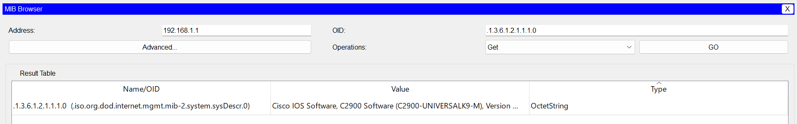
Figure 7: SNMP Get of sysDescr.0 from Router1 (192.168.1.1).
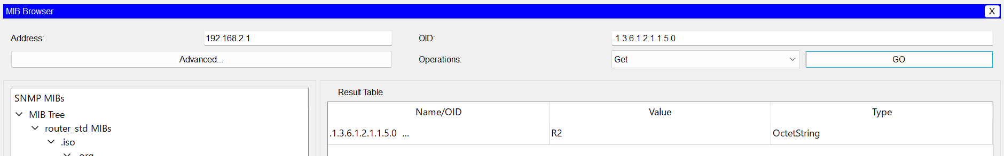
Figure 8: SNMP Get of sysName.0 from Router2 (192.168.2.1).
During setup, the first SNMP request returned Request timed out even though ping to the router worked, which means the network path was fine and the problem was in the SNMP settings. After checking the agent configuration on the router and the community string and version in the manager's Advanced settings, the requests succeeded. Typical causes of this symptom are a missing snmp-server community line on the router or a community string or version mismatch on the manager.

5.5 Packet-level view (Simulation mode)
Simulation mode, filtered to ICMP, was used to watch a ping from PC1 to PC3 move through the network. The event list records each device the packet visits and the time elapsed. The packet crosses Switch1, Router1, Router2 and Switch2 and the echo reply returns along the same path; the PDU list reports the final status Successful. As on the real network, the first attempt may fail while ARP entries are learned.
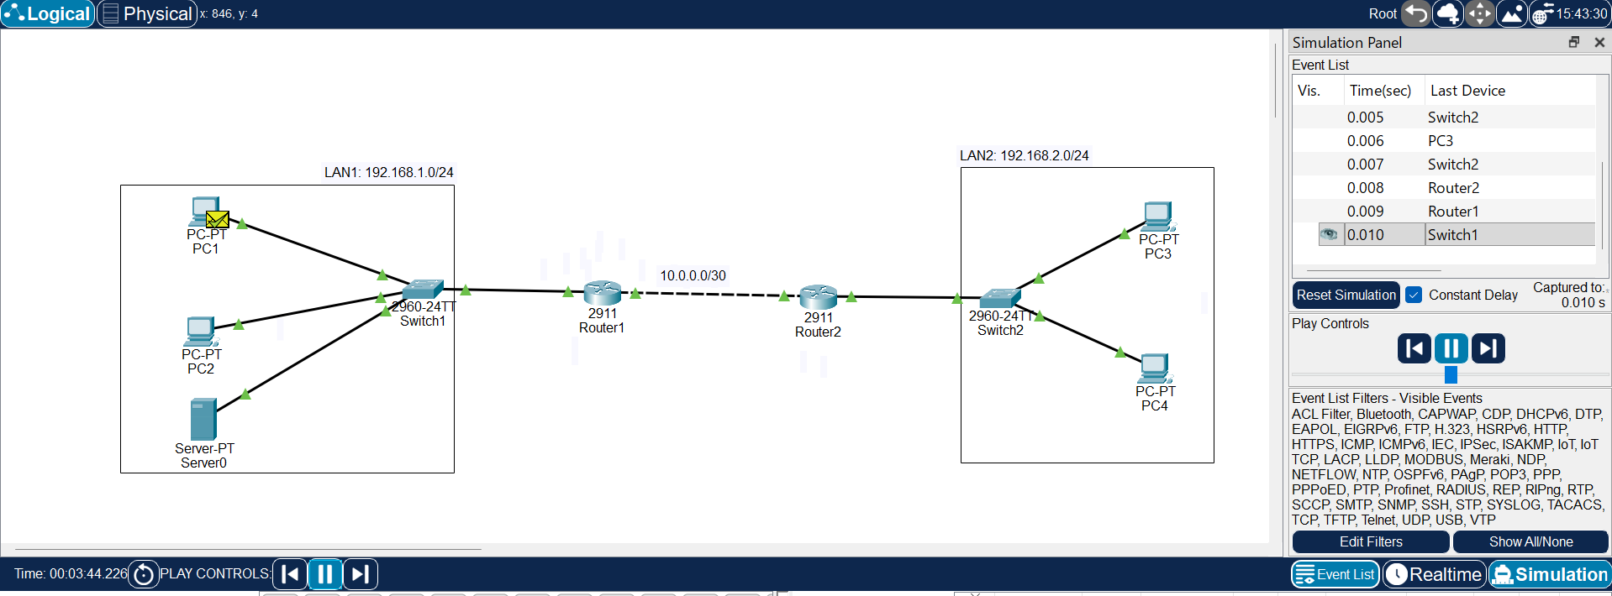
Figure 9: Simulation mode: event list for ICMP between PC1 and PC3, final status Successful.

5.6 Monitoring summary
Tool | What it shows | Where used | Outcome
ping | Reachability, latency, TTL | PC1, PC3 | End-to-end connectivity confirmed
tracert | Hop-by-hop path | PC1 | Path via 192.168.1.1 and 10.0.0.2
show ip interface brief | Interface status | R1, R2 | All used interfaces up/up
show ip route | Learned and connected routes | R1, R2 | RIP routes present
Syslog | Device events in one place | Server0 | Link and config events collected
SNMP (MIB Browser) | Device identity and status | PC1 | Both routers queried remotely
Simulation mode | Packet path and timing | Whole network | Packet flow visualised

6. Troubleshooting

6.1 Method
Each fault was handled with the same repeatable process:
- Baseline: record that the network works before changing anything.
- Identify: describe exactly what fails and what still works.
- Isolate: use the evidence to place the fault on a device or layer (host, switch, router, link).
- Fix: apply the smallest change that removes the root cause.
- Verify: repeat the original failing test and confirm the network is healthy again.

6.2 Incident 1 - Router interface shut down
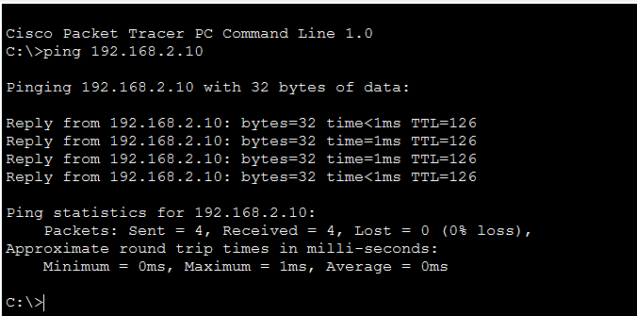
Figure 10: Baseline before the fault: PC1 pings PC3 with 0% loss.
Fault injected on Router1
R1# configure terminal
R1(config)# interface gigabitEthernet 0/1
R1(config-if)# shutdown

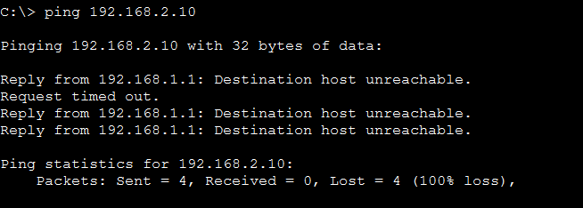
Figure 11: Symptom: ping from PC1 to PC3 fails with 100% loss.
Item | Detail
Symptom | Ping from PC1 to PC3 failed (4 sent, 0 received). The replies were Destination host unreachable and came from 192.168.1.1.
Analysis | A reply from 192.168.1.1 means the packet reached Router1 - so PC1, the cable and Switch1 are fine - and Router1 itself reported that it has no route to 192.168.2.0/24. The fault is therefore at Router1 or on the link to Router2, not in LAN1.
Root cause | Interface GigabitEthernet0/1 on Router1 (the link to Router2) was administratively shut down. With the interface down, Router1 lost the RIP route to 192.168.2.0/24.
Resolution | Re-enable the interface with no shutdown; RIP then re-learned the route.
Verification | The interface returned to up/up, show ip route shows the route to 192.168.2.0/24 again (learned 15 seconds earlier) and ping from PC1 to PC3 succeeds.

Fix
R1# configure terminal
R1(config)# interface gigabitEthernet 0/1
R1(config-if)# no shutdown

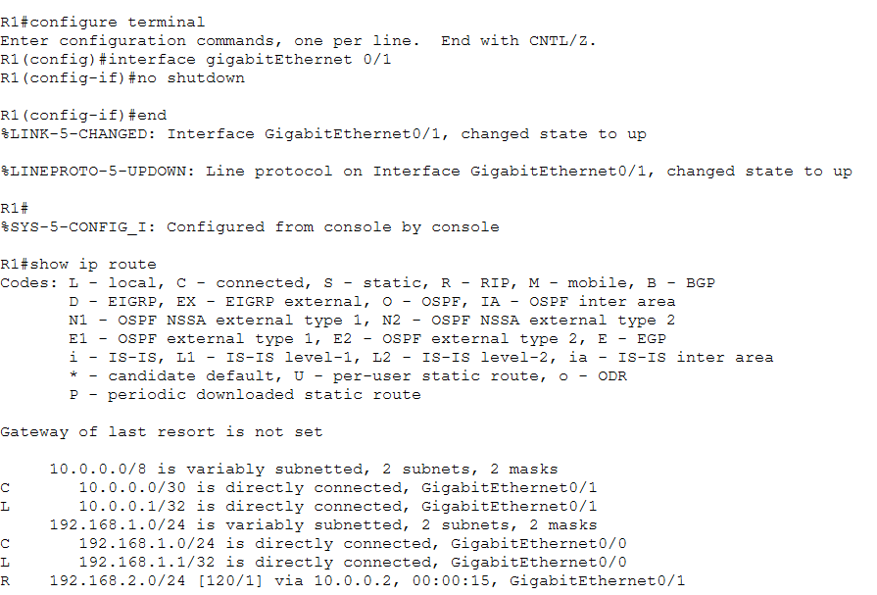
Figure 12: After the fix: interface up and the RIP route to 192.168.2.0/24 restored on Router1.
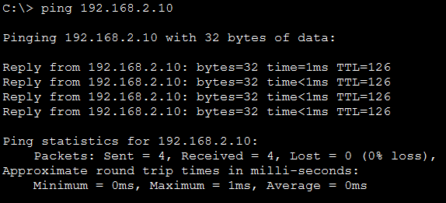
Figure 13: Verification: ping from PC1 to PC3 succeeds again (4/4, TTL=126).

6.3 Incident 2 - Wrong default gateway on a host
The default gateway on PC3 was changed from 192.168.2.1 to 192.168.2.254, an address that does not exist.
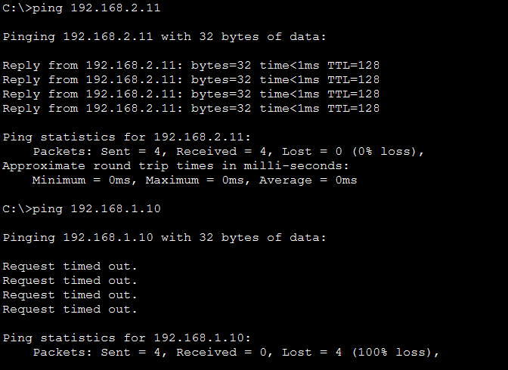
Figure 14: Symptom: PC3 reaches PC4 in its own LAN (TTL=128) but pings to PC1 time out.
Item | Detail
Symptom | PC3 could ping PC4 in the same subnet but could not reach anything outside LAN2 (request timed out).
Analysis | Local traffic works, so the NIC, cable and Switch2 are fine. Remote traffic fails, which points to the default gateway. Unlike Incident 1, no device answered at all: the packets were addressed to a gateway that does not exist.
Diagnosis | Ping to the configured gateway 192.168.2.254 timed out, while ping to the real router interface 192.168.2.1 succeeded (TTL=255, i.e. a router). The router is healthy; only the gateway setting on PC3 is wrong.
Root cause | Incorrect default gateway (192.168.2.254) configured on PC3.
Resolution | Set the default gateway to 192.168.2.1 in IP Configuration.
Verification | ipconfig shows 192.168.2.1 as gateway and ping from PC3 to PC1 succeeds (TTL=126).

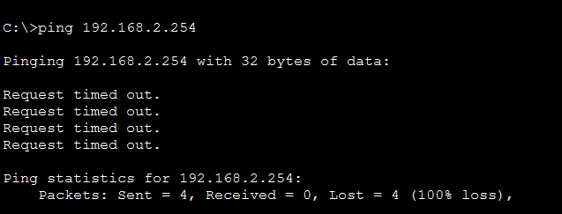
Figure 15: Diagnosis: the wrong gateway 192.168.2.254 does not answer.
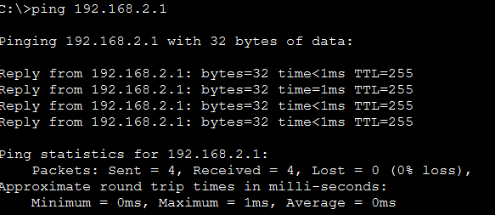
Figure 16: Diagnosis: the real router interface 192.168.2.1 answers (TTL=255).
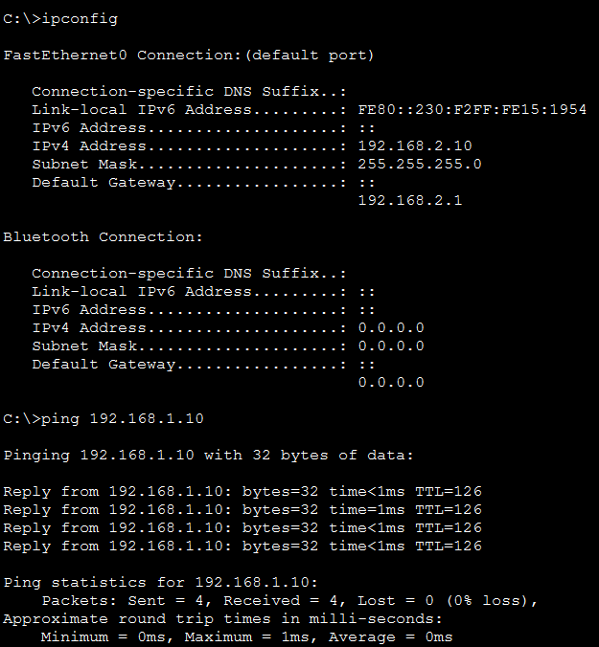
Figure 17: Verification: corrected gateway in ipconfig and successful ping to PC1.

6.4 Incident 3 - Routing process removed from a router
Fault injected on Router2
R2# configure terminal
R2(config)# no router rip

Item | Detail
Fault | The RIP process was removed from Router2. Router2 stops exchanging routes and discards the routes learned from Router1, so it can no longer forward traffic to 192.168.1.0/24.
Expected indicators | show ip route on Router2 shows only connected (C) and local (L) entries and no R entry for 192.168.1.0/24; show ip protocols no longer lists RIP.
Root cause | Missing routing configuration on Router2 (dynamic routing disabled), not a physical or addressing problem - all interfaces stayed up.
Resolution | Re-create the RIP configuration on Router2 (commands below) and save it.
Verification | Router2 again lists 192.168.1.0/24 as a RIP route via 10.0.0.1, learned a few seconds after the configuration was re-applied (see figure), so forwarding between the two LANs is possible again.

Fix
R2# configure terminal
R2(config)# router rip
R2(config-router)# version 2
R2(config-router)# network 192.168.2.0
R2(config-router)# network 10.0.0.0
R2(config-router)# no auto-summary
R2(config-router)# end
R2# write memory

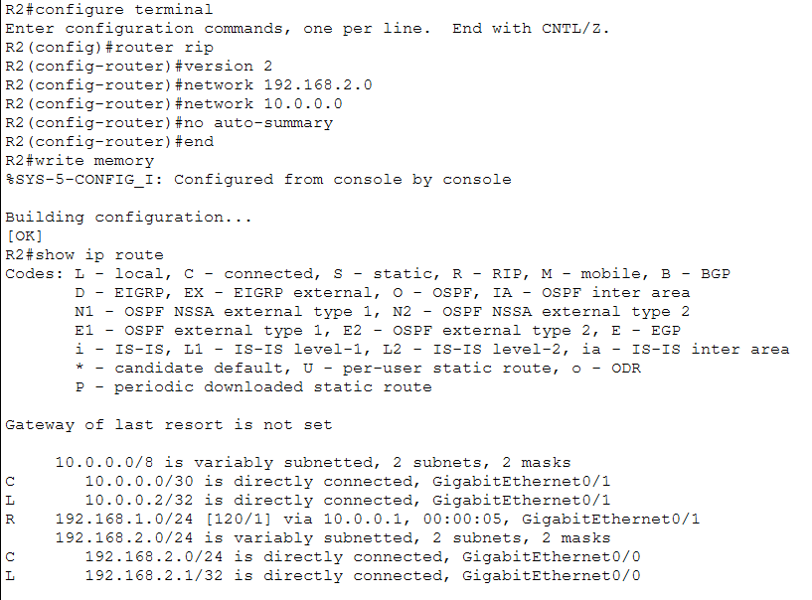
Figure 18: After the fix: Router2 learns 192.168.1.0/24 via RIP from 10.0.0.1.

6.5 Incident summary
# | Fault | Layer / area | Key evidence | Fix
1 | Router interface shut down | Network / interface | Unreachable reply from 192.168.1.1; route missing | no shutdown
2 | Wrong default gateway on PC3 | Network / host configuration | Local ping OK, remote ping times out | Gateway set to 192.168.2.1
3 | RIP removed from Router2 | Network / routing | No R entries in routing table | Re-create router rip

7. Conclusion and recommendations
The simulation met every objective: a working two-LAN routed network was designed and configured, monitored with ping, traceroute, Syslog, SNMP and Simulation mode, and three different classes of fault were diagnosed and fixed using evidence rather than guesswork. The most useful lessons were:
- The source of an error message matters. The unreachable reply from the gateway in Incident 1 immediately narrowed the fault to Router1, while the silence in Incident 2 pointed at the gateway setting.
- Comparing what still works (same-subnet ping, router ping) with what fails is the quickest way to locate a fault.
- Centralised logging and SNMP give visibility without logging in to every device.
- A failed first ping is often just ARP; re-test before concluding that something is broken.
Recommended improvements for a production network:
- Replace the default public/private SNMP community strings, remove the read-write community and prefer SNMPv3.
- Restrict SNMP and Syslog access with access lists and add NTP so log timestamps are meaningful.
- Add a redundant link between the routers so that one failed interface does not split the network.
- Save configurations after every change and keep a backup copy (Appendix A).

Appendix A - Configuration commands
The listings below contain the commands applied to each device. They are the working configuration scripts for this lab and can be pasted into the CLI of an equivalent topology.
Router1 (R1)
enable
configure terminal
hostname R1
interface gigabitEthernet 0/0
ip address 192.168.1.1 255.255.255.0
no shutdown
exit
interface gigabitEthernet 0/1
ip address 10.0.0.1 255.255.255.252
no shutdown
exit
router rip
version 2
network 192.168.1.0
network 10.0.0.0
no auto-summary
exit
logging host 192.168.1.100
snmp-server community public ro
snmp-server community private rw
end
write memory

Router2 (R2)
enable
configure terminal
hostname R2
interface gigabitEthernet 0/0
ip address 192.168.2.1 255.255.255.0
no shutdown
exit
interface gigabitEthernet 0/1
ip address 10.0.0.2 255.255.255.252
no shutdown
exit
router rip
version 2
network 192.168.2.0
network 10.0.0.0
no auto-summary
exit
logging host 192.168.1.100
snmp-server community public ro
snmp-server community private rw
end
write memory

End devices (static addressing)
Device | IP address | Mask | Gateway
PC1 | 192.168.1.10 | 255.255.255.0 | 192.168.1.1
PC2 | 192.168.1.11 | 255.255.255.0 | 192.168.1.1
Server0 (Syslog ON) | 192.168.1.100 | 255.255.255.0 | 192.168.1.1
PC3 | 192.168.2.10 | 255.255.255.0 | 192.168.2.1
PC4 | 192.168.2.11 | 255.255.255.0 | 192.168.2.1

Appendix B - Command reference
Command | Purpose
show ip interface brief | Interface status and IP addresses
show ip route | Routing table (C, L, R entries)
show ip protocols | Routing protocols running on the router
show logging | Local log buffer and Syslog settings
ping <ip> | Test reachability and round-trip time
tracert <ip> | Show the path to a destination (PC command prompt)
ipconfig | Show host IP address, mask and gateway
interface <x> / shutdown / no shutdown | Disable or enable an interface
write memory | Save the running configuration

